A PROJECT REPORT
ON
"FinTrack – Expense Tracking System"

Submitted in partial fulfilment for the award of degree of
"BACHELOR IN COMPUTER APPLICATION"
(BCA-III)
To the
Punyashlok Ahilyadevi Holkar Solapur University, Solapur

Submitted by
Mr. Samarth Mahimkar [233032]
Mr. Sanket Soma [233062]

PRIN. K.P. MANGALVEDHEKAR INSTITUTE
OF MANAGEMENT, CAREER DEVELOPMENT
AND RESEARCH, SOLAPUR.
(KPMIM)

Under the Guidance of
Prof. Suhas Kulkarni

2025–2026

CERTIFICATE

This is to certify that the project work entitled "FinTrack – Expense Tracking System" is being submitted herewith for the award of Degree of B.C.A. (Sem – VI) under the Faculty of Science of Punyashlok Ahilyadevi Holkar Solapur University, Solapur and is the result of original work completed by Mr. Samarth Mahimkar [233032] and Mr. Sanket Soma [233062] under the supervision and guidance of Prof. Suhas Kulkarni. To the best of our knowledge and belief, the work embodied in this project is completed by the above-mentioned students.

Place: Solapur
Date: ___________

Project Guide  Prof. Suhas Kulkarni | External Examiner  ___________ | Head of Department  ___________ | Director  Dr. O.M. Ashtankar

College / Institute Seal
DECLARATION
We, the undersigned, hereby declare that the project report entitled,
"FinTrack – Expense Tracking System"
written and submitted by us is our original work and has been carried out under the guidance of Prof. Suhas Kulkarni, Department of Computer Science, Prin. K.P. Mangalvedhekar Institute of Management, Career Development and Research, Solapur.

The findings presented in this report are based on our own work. While preparing this report, we have not copied from any other report or website. We understand that any such copying is liable to be punished in a manner that the university authorities deem fit.

The results embodied in this report have not been submitted to any other university or institution for the award of any degree.

Name of the Students:  Mr. Samarth Mahimkar  Mr. Sanket Soma | Signature  ___________  ___________

Place: Solapur
Date: ___________

ACKNOWLEDGEMENT
A word of thanks is much less for the encouragement we have received from people who went out of their way to make things simple for us and helped us complete this project. From the bottom of our hearts, we thank the Director of the Institute, Dr. O.M. Ashtankar, who gave us the opportunity to undertake and submit this project.

Our special thanks and sincere gratitude go to our Project Guide, Prof. Suhas Kulkarni, whose constant guidance, constructive criticism, and unwavering support throughout the development and documentation of this project made its successful completion possible. Without his mentorship, this work would not have been achievable.
We are also thankful to our friends and fellow students who provided encouragement and assistance throughout the preparation and development of this project.

Mr. SAMARTH MAHIMKAR
Mr. SANKET SOMA
B.C.A – III

Place: Solapur
Date: ___________

Prin. K.P. Mangalvedhekar Institute of Management Career Development and Research

INDEX
SR. NO. | CHAPTER DETAILS | PAGE NO.
 | PRELIMINARY PAGES
1 | Title Page | i
2 | Certificate | ii
3 | Declaration | iii
4 | Acknowledgement | iv
5 | Index | v
 | CHAPTER 1: INTRODUCTION
1 | 1.1 Existing System and Need for System | 1
2 | 1.2 Scope of Work | 3
3 | 1.3 Operating Environment – Hardware and Software | 4
4 | 1.4 Detail Description of Technology Used | 5
 | CHAPTER 2: PROPOSED SYSTEM
1 | 2.1 Proposed System | 9
2 | 2.2 Objectives of System | 10
3 | 2.3 User Requirements | 11
 | CHAPTER 3: ANALYSIS & DESIGN
1 | 3.1 Data Flow Diagram (DFD) | 13
2 | 3.2 Entity Relationship Diagram (ERD) | 15
3 | 3.3 Data Dictionary | 17
4 | 3.4 Table Design | 19
5 | 3.5 Code Design | 21
6 | 3.6 Menu Tree | 22
7 | 3.7 Input Screens | 23
8 | 3.8 Report Formats | 24
9 | 3.9 Test Procedures and Implementation | 25
 | CHAPTER 4: USER MANUAL
1 | 4.1 User Manual | 28
2 | 4.2 Operations Manual / Menu Explanation | 29
3 | 4.3 Forms and Report Specifications | 30
4 | 4.4 Drawbacks and Limitations | 31
5 | 4.5 Proposed Enhancements | 32
 | CHAPTER 5: CONCLUSION | 34
 | 6. BIBLIOGRAPHY | 36
 | 7. ANNEXURES
1 | Annexure 1 – Input Forms with Data | 38
2 | Annexure 2 – Output Reports with Data | 39
3 | Annexure 3 – Sample Code | 40

CHAPTER 1: INTRODUCTION

1.1 Existing System and Need for System

The Existing System
In today's fast-paced world, managing personal finances is a critical yet often neglected aspect of daily life. Most individuals currently rely on traditional methods such as handwritten notebooks, physical registers, or basic spreadsheet files to record their daily expenses. While these methods have served as simple tracking tools for years, they are severely limited in functionality, security, and analytical capability.

A typical manual or spreadsheet-based expense tracking approach suffers from the following fundamental problems:

- No Centralized Access: Expense records maintained in notebooks or local spreadsheets are not accessible from multiple devices. If the file is lost, corrupted, or the device fails, all financial data is permanently lost.
- Lack of Security: Personal financial information stored in notebooks or unprotected spreadsheets is vulnerable to unauthorized access. There is no authentication mechanism to restrict who can view or modify the data.
- No Analytical Capability: Manual systems provide no ability to visualize spending patterns, generate monthly or yearly summaries, or identify category-wise expenditure trends. Users must manually calculate totals, which is time-consuming and error-prone.
- Difficult Data Retrieval: Searching for past expenses based on date, category, or payment mode is practically impossible in a manual system. Users must scan through pages of records to find relevant entries.
- No Export Functionality: Manual systems cannot generate formatted reports. Preparing a financial summary for review requires extensive manual effort.
- Human Error: Manual data entry in registers or spreadsheets is highly susceptible to mathematical errors and incorrect categorization, leading to unreliable financial records.
- Scalability Issues: As the volume of transactions grows over months and years, maintaining and managing manual records becomes increasingly cumbersome and impractical.

Need for the System
The increasing complexity of modern financial life demands a reliable, secure, and intelligent system for personal expense management. The need for FinTrack arises from a clear gap between what existing manual tools offer and what a modern user requires:

- A secure, password-protected system to prevent unauthorized access to personal financial data.
- A centralized web-based platform accessible from any device through a browser.
- Automated analytics that provide instant monthly, yearly, and category-wise summaries without manual calculations.
- The ability to classify expenses into custom categories defined by each individual user.
- Export functionality to generate reports in CSV and PDF formats for record-keeping or sharing.
- Intelligent expense prediction based on historical spending data to help users anticipate future expenses.

FinTrack has been designed and developed specifically to address all of the above needs, providing users with a complete, efficient, and modern personal finance management solution.

1.2 Scope of Work

FinTrack is a full-stack web-based personal expense tracking and financial analysis system. The scope of the project encompasses the following functional boundaries:

- User Management: The system supports user registration and login with JWT-based authentication. Each registered user maintains an independent, isolated account with their own expense and category data.
- Expense Management: Users can add new expenses with details including amount, date, description, payment mode, and category. Expenses can be updated or deleted at any time.
- Category Management: Users can create, view, and delete their own custom expense categories. Default categories are automatically created when a new user registers.
- Analytics and Reporting: The system provides monthly summaries, yearly summaries, and category-wise analysis of expenses. Users can view expense trends over time and predict future spending.
- Report Export: Users can export their expense data in CSV format and generate PDF reports for offline use and record-keeping.
- Security: All REST API endpoints are protected. Only authenticated users with valid JWT tokens can access their own data. Data isolation ensures one user cannot access another user's records.

The system is limited to personal use and does not include enterprise-level financial management, multi-user shared accounts, budget alerts, or mobile application support in the current version.

1.3 Operating Environment – Hardware and Software

Hardware Requirements (recommended)

Component | Minimum Specification
Processor | Intel Core i3 or equivalent (1.6 GHz or above)
RAM | 4 GB (8 GB recommended)
Storage | 10 GB free disk space
Display | 1024 x 768 resolution or higher
Network | Local network / localhost for development
Input Devices | Keyboard and Mouse

Software Requirements

Category | Software / Tool | Version
Operating System | Microsoft Windows | Windows 10/11
Backend Runtime | Java Development Kit (JDK) | JDK 21
Backend Framework | Spring Boot | 3.x
Frontend Runtime | Node.js + npm | Node.js 18+
Frontend Framework | React.js | 18.x
Database | MySQL | 8.0
Build Tool | Apache Maven | 3.9+
API Testing | Postman | Latest
Code Editor | IntelliJ IDEA / VS Code | Latest
API Documentation | Swagger UI | 3.x
Version Control | Git | Latest

Deployment Configuration
- Backend Server URL: http://localhost:8080
- Frontend Server URL: http://localhost:5173
- Database Host: localhost:3306

1.4 Detail Description of Technology Used

1.4.1 Java (JDK 21)
Java is a robust, platform-independent, object-oriented programming language. JDK 21 is the Long-Term Support (LTS) version used as the primary backend programming language for FinTrack. Java provides strong type safety, exception handling, and multi-threading support which are essential for building secure and scalable REST APIs.

1.4.2 Spring Boot
Spring Boot is a Java-based open-source framework that simplifies the creation of production-ready web applications. It eliminates the need for complex XML configuration through auto-configuration. FinTrack uses Spring Boot to create the REST API backend, manage dependency injection, and configure the entire application lifecycle.

1.4.3 Spring Security with JWT Authentication
Spring Security is a powerful authentication and access-control framework for Java applications. FinTrack uses Spring Security in combination with JSON Web Tokens (JWT) to implement stateless authentication. When a user logs in, the server generates a signed JWT token. This token is sent with every subsequent API request in the HTTP Authorization header. The server validates the token before granting access to protected resources, ensuring that unauthorized users cannot access any expense or category data.

1.4.4 Spring Data JPA and Hibernate
Spring Data JPA provides a repository abstraction layer over the Java Persistence API (JPA). Hibernate, the underlying ORM (Object-Relational Mapping) framework, maps Java entity classes to MySQL database tables. This eliminates the need to write raw SQL queries for most operations. CRUD operations on the USERS, CATEGORIES, and EXPENSES tables are handled entirely through JPA repositories.

1.4.5 MySQL 8.0
MySQL is an open-source relational database management system (RDBMS). Version 8.0 provides enhanced performance, improved security, and support for JSON data types. FinTrack uses MySQL to store all user, category, and expense data in a normalized relational schema with three core tables. Foreign key constraints enforce referential integrity across tables.

1.4.6 React.js
React.js is an open-source JavaScript library developed by Meta (formerly Facebook) for building dynamic and interactive user interfaces. FinTrack uses React.js for the frontend, enabling a Single Page Application (SPA) architecture. Components are built for each feature such as the login page, expense entry form, analytics dashboard, and category manager. React communicates with the Spring Boot backend through RESTful API calls.

1.4.7 HTML5 and CSS3
HTML5 provides the structural markup for all pages and forms in the FinTrack frontend. CSS3 is used for styling, layout design, and ensuring a responsive and user-friendly interface. Together, they form the visual layer of the application.

1.4.8 Apache Maven
Maven is a project management and build automation tool for Java applications. FinTrack uses Maven to manage all backend dependencies including Spring Boot starters, JWT libraries, Hibernate, and MySQL connector. The pom.xml file defines the complete dependency tree and build configuration.

1.4.9 Swagger UI
Swagger provides interactive API documentation for REST APIs. FinTrack integrates Swagger so that all API endpoints, their request formats, response structures, and authentication requirements can be viewed and tested directly through a browser interface at http://localhost:8080/swagger-ui.html.

1.4.10 Postman
Postman is an API testing tool used during the development and testing phase of FinTrack. All REST API endpoints including registration, login, expense CRUD, category management, and analytics were tested using Postman to verify correct request-response behavior and JWT token validation.

CHAPTER 2: PROPOSED SYSTEM

2.1 Proposed System

FinTrack is a proposed full-stack web-based personal expense tracking and financial analysis system designed to replace the inefficiencies of manual and spreadsheet-based expense management. The system is built using Java Spring Boot for the backend, React.js for the frontend, and MySQL 8.0 as the relational database, connected through a well-defined REST API architecture.

The proposed system is a multi-user platform where each registered individual maintains a completely isolated account. Users can securely register and log in using JWT-based authentication. Once authenticated, they can create custom expense categories, record daily expenses with detailed information including amount, date, description, and payment mode, and access comprehensive analytics of their financial behavior.

The system processes all analytical data dynamically at runtime using the stored expense records, eliminating the need for separate analytics tables. Users can view monthly and yearly expense summaries, category-wise breakdowns, and predicted future expenses. The system also allows users to export their data in CSV and PDF formats for offline record-keeping.

The proposed system runs on a local development environment with the backend at http://localhost:8080 and the frontend at http://localhost:5173. All API endpoints are documented through Swagger UI and were tested using Postman during development.

Characteristics of the Proposed System
- Secure JWT-based user authentication ensuring only authorized users can access their own data.
- Complete data isolation – no user can view or modify another user's expenses or categories.
- Dynamic analytics computed at runtime from stored expense data without any pre-stored aggregation.
- Default categories automatically assigned to new users upon registration.
- Support for six fixed payment modes: Cash, UPI, Debit Card, Credit Card, Bank Transfer, and Other.
- Export of expense reports in CSV and PDF formats.
- Layered Spring Boot architecture ensuring clean separation of concerns between controller, service, repository, and security layers.
- Fully documented REST APIs using Swagger UI.

2.2 Objectives of System

The primary objectives of the FinTrack Expense Tracking System are as follows:

- To provide individual users with a secure, web-based platform for recording and managing their personal daily expenses.
- To implement JWT-based authentication so that each user's data is protected and accessible only by the rightful account holder.
- To allow users to organize expenses into custom categories for better financial classification and analysis.
- To generate automated monthly and yearly expense summaries without requiring manual calculations.
- To provide category-wise analysis of spending patterns, enabling users to understand where their money is being spent.
- To implement an expense prediction feature that uses historical data to estimate future spending trends.
- To enable export of financial data in CSV and PDF formats for offline review and record-keeping.
- To develop a responsive, user-friendly frontend interface using React.js that communicates with the backend through REST APIs.
- To ensure data integrity through server-side validation including prevention of future-dated expenses and enforcement of non-zero expense amounts.
- To follow a clean, maintainable layered software architecture that allows for future enhancements and scalability.

2.3 User Requirements

Functional Requirements

The following functional requirements were identified for the FinTrack system:

- The system shall allow new users to register with their full name, email address, and password.
- The system shall allow registered users to log in and receive a JWT token for authenticated access.
- The system shall allow authenticated users to add, view, update, and delete expense records.
- Each expense record shall contain amount, date, description, payment mode, and category.
- The system shall allow users to create, view, and delete their own expense categories.
- Default categories shall be automatically created for every new user at the time of registration.
- The system shall display a monthly summary showing total expenses for the selected month.
- The system shall display a yearly summary showing total expenses for the selected year.
- The system shall display category-wise expense breakdown for any given time period.
- The system shall display expense prediction based on historical monthly averages.
- The system shall allow users to export their expense data as a CSV file.
- The system shall allow users to generate and download a PDF expense report.

Non-Functional Requirements

- Security: All API endpoints except registration and login shall require a valid JWT token. Passwords shall be stored in encrypted form using BCrypt hashing.
- Data Integrity: The system shall validate that expense amounts are greater than zero and that expense dates are not set in the future.
- Data Isolation: Each user shall be able to access only their own expense and category data.
- Performance: The system shall respond to standard API requests within an acceptable time on a local development environment.
- Usability: The React.js frontend shall provide a clean, intuitive interface that requires minimal training to operate.
- Maintainability: The codebase shall follow a layered architecture pattern ensuring clean separation of concerns.

CHAPTER 3: ANALYSIS & DESIGN

3.1 Data Flow Diagram (DFD)

DFD Level 0 (Context level)
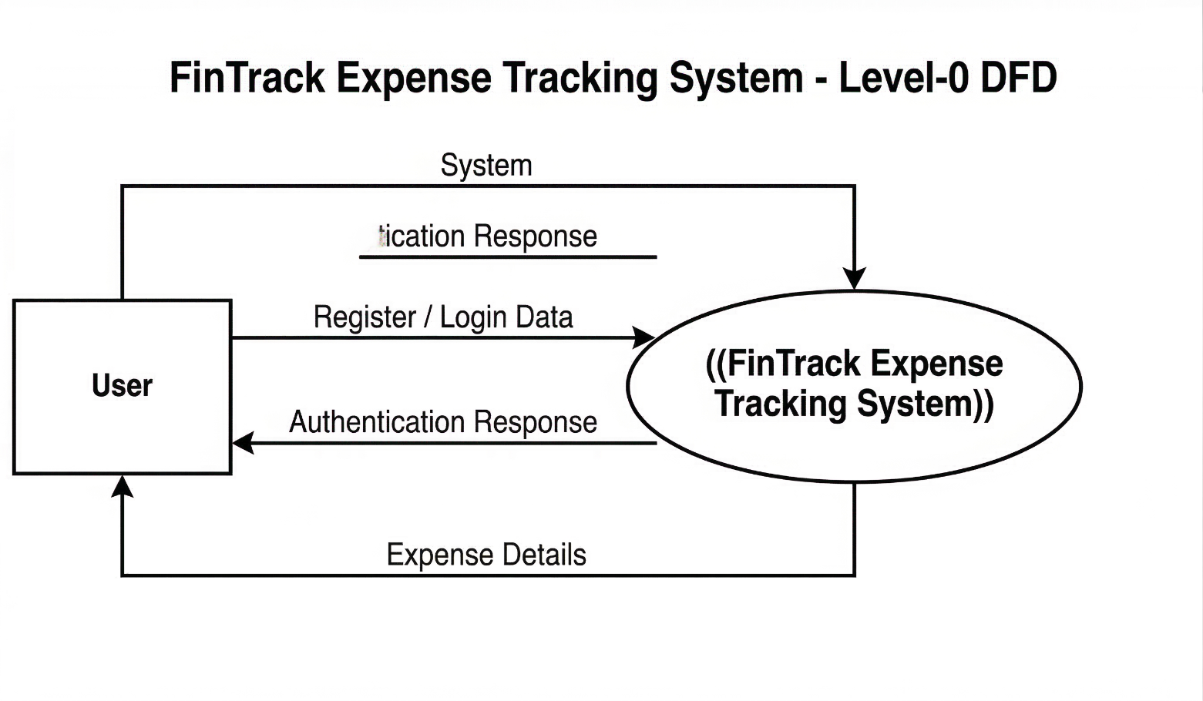
DFD Level 1:

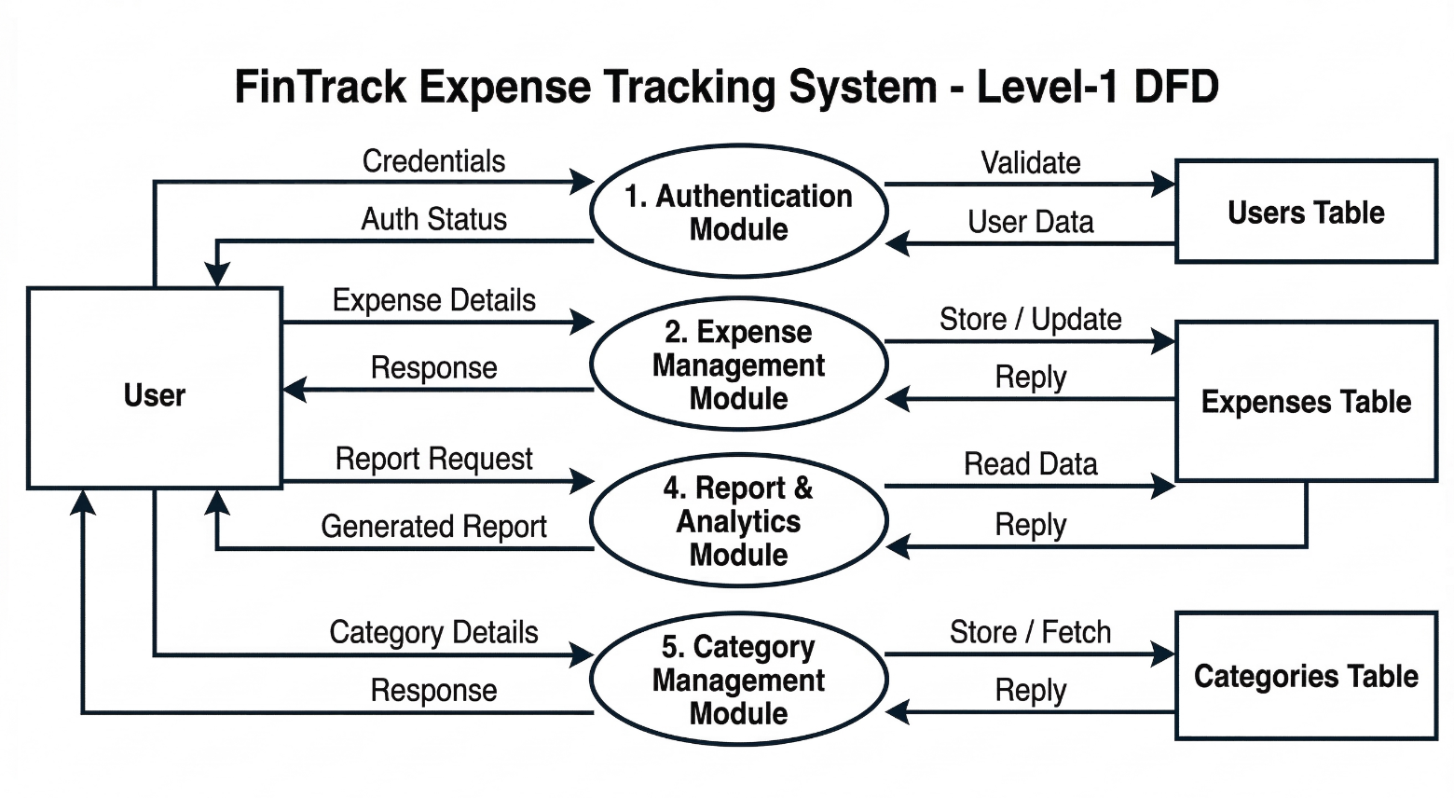

DFD Level 2: 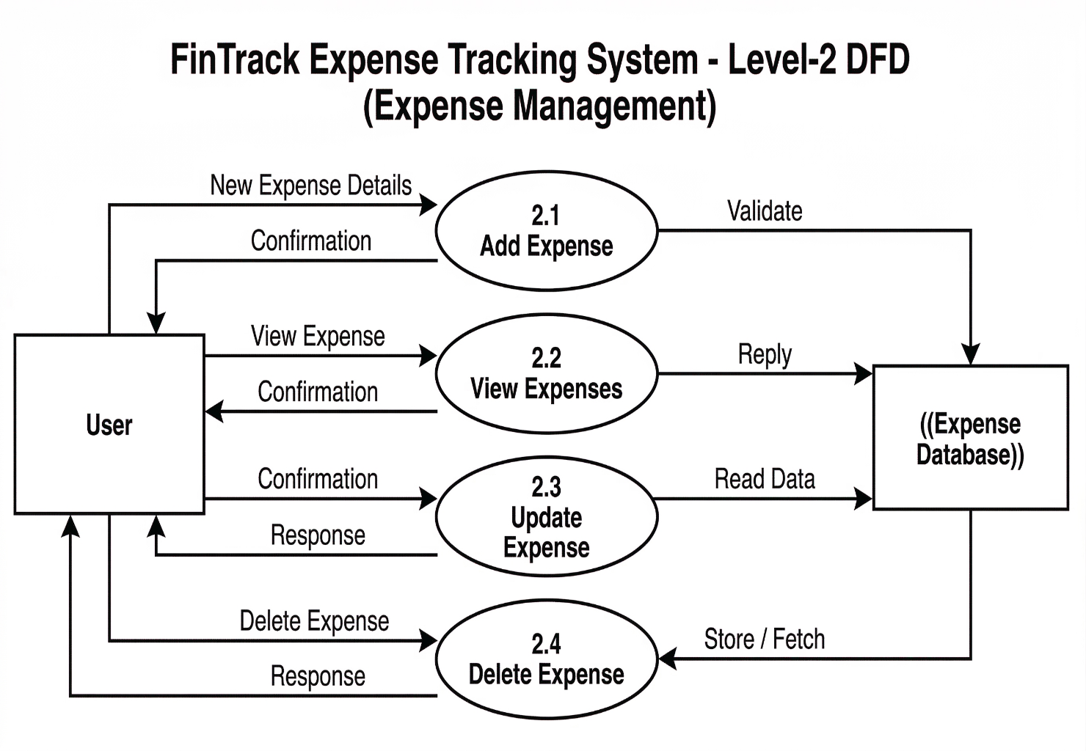

3.2 Entity Relationship Diagram (ERD)

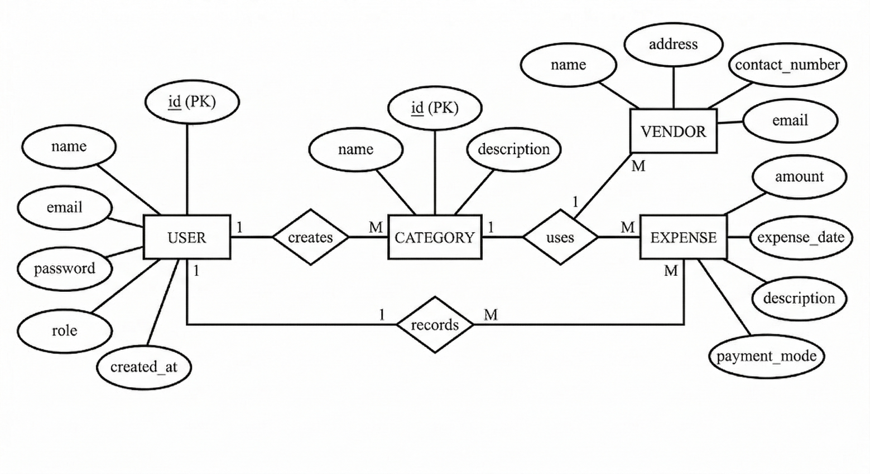
3.3 Data Dictionary

The Data Dictionary describes the structure of each attribute in the FinTrack database tables, including its data type, constraints, and purpose.

Table: USERS
Sr.No. | Column Name | Data Type | Constraint | Description
1 | id | BIGINT | Primary Key, Auto Increment, Not Null | Unique identifier for each user
2 | name | VARCHAR(255) | Not Null | Full name of the registered user
3 | email | VARCHAR(255) | Unique, Not Null | Email address used for login (must be unique)
4 | password | VARCHAR(255) | Not Null | BCrypt-encrypted password of the user
5 | role | VARCHAR(50) | Nullable | Role of the user (default: USER)
6 | created_at | DATETIME | Nullable | Timestamp of user account creation

Table: CATEGORIES
Sr.No. | Column Name | Data Type | Constraint | Description
1 | id | BIGINT | Primary Key, Auto Increment, Not Null | Unique identifier for each category
2 | name | VARCHAR(255) | Not Null | Name of the expense category
3 | description | VARCHAR(255) | Nullable | Optional description of the category
4 | user_id | BIGINT | Foreign Key → USERS(id), Not Null | Owner of this category

Table: EXPENSES
Sr.No. | Column Name | Data Type | Constraint | Description
1 | id | BIGINT | Primary Key, Auto Increment, Not Null | Unique identifier for each expense
2 | amount | DECIMAL(10,2) | Not Null, Must be > 0 | Monetary value of the expense
3 | date | DATE | Not Null, Cannot be future date | Date on which the expense was incurred
4 | description | VARCHAR(255) | Nullable | Brief description or note about the expense
5 | payment_mode | VARCHAR(50) | Nullable | Mode of payment: Cash, UPI, Debit Card, Credit Card, Bank Transfer, Other
6 | user_id | BIGINT | Foreign Key → USERS(id), Not Null | User who recorded this expense
7 | category_id | BIGINT | Foreign Key → CATEGORIES(id), Not Null | Category under which the expense is classified

3.4 Table Design

The following tables define the complete physical design of the FinTrack MySQL 8.0 database including all field names, data types, constraints, and relationships.

Table 1: USERS
Sr.No. | Field Name | Data Type | Constraint | Description
1 | id | BIGINT | PK, AI, NOT NULL | Auto-incremented unique user ID
2 | name | VARCHAR(255) | NOT NULL | User's full name
3 | email | VARCHAR(255) | UNIQUE, NOT NULL | User's email for authentication
4 | password | VARCHAR(255) | NOT NULL | BCrypt hashed password
5 | role | VARCHAR(50) | NULL | User role (default: USER)
6 | created_at | DATETIME | NULL | Account creation timestamp

Table 2: CATEGORIES
Sr.No. | Field Name | Data Type | Constraint | Description
1 | id | BIGINT | PK, AI, NOT NULL | Auto-incremented category ID
2 | name | VARCHAR(255) | NOT NULL | Category name (e.g., Food, Travel)
3 | description | VARCHAR(255) | NULL | Optional category description
4 | user_id | BIGINT | FK → USERS(id), NOT NULL | Owner user reference

Table 3: EXPENSES
Sr.No. | Field Name | Data Type | Constraint | Description
1 | id | BIGINT | PK, AI, NOT NULL | Auto-incremented expense ID
2 | amount | DECIMAL(10,2) | NOT NULL | Expense amount (must be > 0)
3 | date | DATE | NOT NULL | Date of expense (no future dates)
4 | description | VARCHAR(255) | NULL | Expense note or description
5 | payment_mode | VARCHAR(50) | NULL | Payment method used
6 | user_id | BIGINT | FK → USERS(id), NOT NULL | User who owns this expense
7 | category_id | BIGINT | FK → CATEGORIES(id), NOT NULL | Category of the expense

3.5 Code Design

FinTrack follows a layered MVC + Service + Repository architecture implemented in Java Spring Boot. The base package is com.fintrack. The code is organized into the following layers:

Layer / Package | Classes | Responsibility
controller/ | AuthController, ExpenseController, CategoryController, AnalyticsController | Handle HTTP requests and return REST responses
service/ | ExpenseService, CategoryService, AnalyticsService | Business logic, data validation, processing
repository/ | UserRepository, ExpenseRepository, CategoryRepository | Spring Data JPA – DB operations
model/ | User, Expense, Category | JPA Entity classes mapping to DB tables
dto/ | Request/Response DTOs | Data Transfer Objects for API payloads
security/ | JwtFilter, JwtUtil, UserDetailsServiceImpl | JWT generation, validation, user auth
config/ | SecurityConfig, CorsConfig | Spring Security and CORS setup
exception/ | Custom exceptions + GlobalExceptionHandler | Unified error handling via @ControllerAdvice
utils/ | Utility helper classes | Reusable utility methods

3.6 Menu Tree

The following menu tree represents the navigation flow available to an authenticated user in the FinTrack system:

FinTrack Application
- Register / Login (Public)
- Dashboard
  - Expense Overview
  - Quick Summary
- Expense Management
  - Add New Expense
  - View All Expenses
  - Edit / Update Expense
  - Delete Expense
- Category Management
  - Add Category
  - View All Categories
  - Delete Category
- Analytics and Reports
  - Monthly Summary
  - Yearly Summary
  - Category-wise Analysis
  - Expense Prediction
  - Export Report (CSV / PDF)
- Account / Logout

3.7 Input Screens

Screen 1: User Registration
The registration screen collects the following inputs from the new user:
- Full Name (text input) – required
- Email Address (email input) – required, must be unique
- Password (password input) – required
- Confirm Password (password input) – required, must match password
- Register button – submits the form and creates a new user account

Screen 2: User Login
The login screen accepts:
- Email Address (email input) – required
- Password (password input) – required
- Login button – authenticates the user and returns a JWT token

Screen 3: Add Expense
The Add Expense form accepts the following inputs:
- Amount (decimal number) – required, must be greater than 0
- Date (date picker) – required, must not be a future date
- Description (text input) – optional notes about the expense
- Payment Mode (dropdown) – one of: Cash, UPI, Debit Card, Credit Card, Bank Transfer, Other
- Category (dropdown) – user's existing categories
- Save / Submit button

Screen 4: Add Category
- Category Name (text input) – required
- Description (text input) – optional
- Add Category button

3.8 Report Formats

Monthly Summary Report
Displays the total expenses for each month of a selected year, grouped by category. Fields shown: Month, Category, Total Amount, Number of Transactions.

Yearly Summary Report
Displays the total expenses for each year available in the user's records. Fields shown: Year, Total Amount, Most Expensive Category.

Category-wise Analysis Report
Displays total spending per category for a selected period. Fields shown: Category Name, Total Amount Spent, Percentage of Total Expenditure.

Expense Prediction Report
Displays predicted expense amounts for upcoming months based on historical monthly averages. Fields shown: Month, Predicted Amount.

CSV Export
The CSV export generates a comma-separated values file containing all expense records. Fields: id, amount, date, description, payment_mode, category_name.

PDF Export
The PDF export generates a formatted document summarizing the user's expense data including header information, table of expenses, and totals.

3.9 Test Procedures and Implementation

The FinTrack system was tested using two methods: Postman for REST API testing and manual testing through the React.js frontend. The following test cases were executed:

TC# | Module | Test Input | Expected Output | Actual Output | Status
TC01 | Registration | Valid name, email, password | User registered, 201 Created | User registered, 201 Created | PASS
TC02 | Registration | Duplicate email | 409 Conflict – Email already exists | 409 Conflict returned | PASS
TC03 | Login | Valid credentials | 200 OK with JWT token | JWT token returned | PASS
TC04 | Login | Invalid password | 401 Unauthorized | 401 Unauthorized returned | PASS
TC05 | Add Expense | Valid amount, date, category | Expense saved, 201 Created | Expense saved successfully | PASS
TC06 | Add Expense | Amount = 0 | 400 Bad Request – validation error | Validation error returned | PASS
TC07 | Add Expense | Future date | 400 Bad Request – date invalid | Validation error returned | PASS
TC08 | Update Expense | Valid updated fields | Expense updated, 200 OK | Expense updated successfully | PASS
TC09 | Delete Expense | Valid expense ID | Expense deleted, 200 OK | Expense deleted successfully | PASS
TC10 | Add Category | Valid category name | Category created, 201 Created | Category created successfully | PASS
TC11 | Delete Category | Valid category ID | Category deleted, 200 OK | Category deleted successfully | PASS
TC12 | Monthly Summary | Valid month/year | Summary data returned | Correct summary returned | PASS
TC13 | Export CSV | Authenticated request | CSV file downloaded | CSV file generated correctly | PASS
TC14 | Access without token | No Authorization header | 401 Unauthorized | 401 Unauthorized returned | PASS

Implementation
The FinTrack system was implemented in the following phases:

- Requirements Gathering: User requirements were identified and documented based on the problems of the existing manual expense tracking system.
- Database Design: The MySQL 8.0 database schema was designed with three normalized tables – USERS, CATEGORIES, and EXPENSES – with appropriate primary and foreign key constraints.
- Backend Development: The Spring Boot backend was developed with layered architecture including controllers, services, repositories, entity models, DTOs, security configuration, and exception handlers.
- Security Implementation: Spring Security with JWT was configured to protect all API endpoints. BCrypt password encoding was applied during user registration.
- Frontend Development: The React.js frontend was developed with component-based architecture, communicating with the backend through REST API calls using JWT tokens in headers.
- Testing: API endpoints were tested using Postman. Frontend flows were tested manually through the browser. Validation rules were verified with boundary input values.

CHAPTER 4: USER MANUAL

4.1 User Manual

This section provides step-by-step instructions for using the FinTrack – Expense Tracking System. The system runs on a local development environment. The frontend is accessible at http://localhost:5173 through any modern web browser.

Step 1: Starting the Application
- Start the MySQL 8.0 database server and ensure the FinTrack database is created.
- Run the Spring Boot backend using Maven: mvn spring-boot:run (runs at http://localhost:8080).
- Run the React.js frontend using npm: npm run dev (runs at http://localhost:5173).
- Open a web browser and navigate to http://localhost:5173.

Step 2: User Registration
- Click the 'Sign Up' or 'Register' link on the login page.
- Enter your full name, a valid email address, and a secure password.
- Confirm the password in the confirmation field.
- Click the 'Register' button. Upon success, default expense categories will be created automatically for your account.
- You will be redirected to the login page.

Step 3: Logging In
- Enter your registered email address and password.
- Click the 'Login' button.
- Upon successful authentication, a JWT token is stored in the browser session and you are redirected to the main dashboard.

Step 4: Adding an Expense
- Navigate to the Expense Management section from the menu.
- Click 'Add Expense' to open the expense entry form.
- Enter the amount (must be greater than 0), select a date (cannot be a future date), and enter an optional description.
- Select a payment mode from the dropdown: Cash, UPI, Debit Card, Credit Card, Bank Transfer, or Other.
- Select the appropriate category from your category list.
- Click 'Save' to record the expense.

Step 5: Managing Categories
- Navigate to the Category Management section.
- View your existing categories, including the default categories created at registration.
- To add a new category, enter the category name and an optional description, then click 'Add Category'.
- To delete a category, click the delete icon next to the category name.

Step 6: Viewing Analytics
- Navigate to the Analytics and Reports section.
- Select 'Monthly Summary' to view total expenses for a selected month.
- Select 'Yearly Summary' to view annual expense totals.
- Select 'Category-wise Analysis' to see how much was spent in each category.
- Select 'Expense Prediction' to view estimated future expenses based on historical averages.

Step 7: Exporting Reports
- In the Analytics section, click 'Export CSV' to download all expense records as a CSV file.
- Click 'Export PDF' to generate and download a formatted PDF report of your expenses.

Step 8: Logging Out
- Click the 'Logout' option from the navigation menu or account settings.
- The JWT token is cleared from the browser session and you are redirected to the login page.

4.2 Operations Manual / Menu Explanation

The FinTrack system provides the following menu options and their operations:

Menu Option | Description / Operation
Register | Creates a new user account. Default categories are automatically assigned upon registration.
Login | Authenticates the user using email and password. Returns a JWT token for session management.
Dashboard | Displays a quick overview of the user's recent expenses and summary statistics.
Add Expense | Opens the expense entry form. Accepts amount, date, description, payment mode, and category.
View Expenses | Displays a list of all expenses recorded by the logged-in user. Supports filtering by category and date.
Edit Expense | Allows modification of any existing expense record including amount, date, category, and description.
Delete Expense | Permanently removes the selected expense record from the database.
Add Category | Creates a new expense category linked to the current user's account.
View Categories | Lists all categories created by the user, including default categories created at registration.
Delete Category | Removes the selected category. Ensure no expenses are linked to it before deleting.
Monthly Summary | Displays total expenses grouped by month for a selected year.
Yearly Summary | Displays total expense amounts for each available year in the user's records.
Category Analysis | Shows spending distribution across all categories with percentage breakdown.
Expense Prediction | Calculates and displays predicted future expenses based on historical monthly average spending.
Export CSV | Downloads all expense records in a comma-separated values file for use in spreadsheet tools.
Export PDF | Generates a formatted PDF report of the user's expenses for offline record-keeping.
Logout | Terminates the current session by clearing the JWT token and redirecting to the login page.

4.3 Forms and Report Specifications

The following specifications define the input forms and output reports used in the FinTrack system:

Registration Form
Fields: Full Name (VARCHAR, max 255), Email (VARCHAR, max 255, unique), Password (VARCHAR, min 6 chars), Confirm Password. Validation: Email format check, password match, duplicate email check at API level.

Login Form
Fields: Email (VARCHAR), Password (VARCHAR). Validation: Both fields required, credentials verified against USERS table. On success: returns JWT token with user details.

Add/Edit Expense Form
Fields: Amount (DECIMAL, > 0), Date (DATE, not future), Description (VARCHAR, optional), Payment Mode (ENUM: Cash / UPI / Debit Card / Credit Card / Bank Transfer / Other), Category (FK from user's categories). Validation enforced both at frontend and backend levels.

Add Category Form
Fields: Category Name (VARCHAR, required), Description (VARCHAR, optional). The category is automatically linked to the currently logged-in user.

Monthly/Yearly Summary Report
Output fields: Period (Month/Year), Total Expense Amount, Number of Transactions. Computed dynamically from the EXPENSES table using JPA queries grouped by month or year.

Category-wise Report
Output fields: Category Name, Total Amount, Percentage Share. Computed by grouping EXPENSES records by category_id for the authenticated user.

4.4 Drawbacks and Limitations

While FinTrack successfully addresses the core needs of personal expense tracking, the following limitations exist in the current version:

- Not Deployed on Cloud: The system is currently deployed only on a local development environment. It is not hosted on any cloud platform and therefore cannot be accessed remotely from different devices or networks.
- No Budget Alert Notifications: The system does not provide real-time alerts or notifications when a user's spending exceeds a defined budget limit for any category or month.
- No Multi-user Shared Accounts: The system does not support shared accounts between family members or groups. Each user maintains a completely independent account.
- No Mobile Application: FinTrack is a web-based application only. There is no dedicated mobile application for Android or iOS in the current version.
- Single User Role: The system currently implements only one user role. There is no administrator role or dashboard for managing multiple user accounts.
- Payment Modes are Fixed: The payment mode options (Cash, UPI, Debit Card, Credit Card, Bank Transfer, Other) are hardcoded in the system. Users cannot add custom payment modes.
- No Bank Account Integration: The system does not integrate with any bank or UPI platform to automatically import transaction records. All expense entries are manual.

4.5 Proposed Enhancements

The following enhancements are proposed for future versions of FinTrack to improve functionality, user experience, and technical capabilities:

- Cloud Deployment: Deploy the backend and database on a cloud platform such as AWS, Azure, or Heroku, and host the frontend on Netlify or Vercel, enabling access from any device and location.
- Budget Alerts and Notifications: Implement a budget limit feature that allows users to set monthly spending caps per category. Email or in-app notifications will be sent when spending approaches or exceeds the defined limit.
- Mobile Application: Develop a dedicated Android and iOS mobile application using React Native to provide a native mobile experience for expense entry and analytics.
- Advanced AI-based Expense Prediction: Enhance the current historical-average-based prediction with a machine learning model that considers seasonal trends, spending patterns, and category-specific behavior.
- Graphical Dashboards and Visualizations: Integrate interactive charts such as pie charts, bar graphs, and line charts using a library like Chart.js or Recharts to provide visual spending analysis.
- Bank Account and UPI Integration: Integrate with banking APIs or UPI platforms to automatically import and categorize transactions, reducing the need for manual data entry.
- Multi-currency Support: Add support for multiple currencies so that users traveling abroad or managing foreign currency expenses can record and convert amounts accurately.
- Recurring Expense Tracking: Allow users to define recurring expenses such as monthly rent, subscriptions, and EMIs that are automatically recorded at defined intervals.

CHAPTER 5: CONCLUSION

5.1 Conclusion

FinTrack – Expense Tracking System is a full-stack, web-based personal finance management application developed to address the significant shortcomings of traditional manual expense tracking methods. The system was designed and built with the objective of providing individuals with a secure, efficient, and analytically powerful tool to manage their daily financial transactions.

The project successfully demonstrates the integration of modern technologies including Java 21, Spring Boot with Spring Security and JWT authentication, Spring Data JPA with Hibernate, MySQL 8.0, and React.js. The layered architecture of the backend – comprising the controller, service, repository, security, and exception handling layers – ensures clean separation of concerns, making the codebase maintainable and extensible.

The system fulfills all the objectives defined at the outset: secure multi-user authentication with data isolation, complete CRUD operations for expenses and categories, dynamic analytics including monthly summaries, yearly summaries, category-wise analysis, and expense prediction, as well as CSV and PDF export functionality. Server-side validation ensures data integrity by preventing future-dated expenses and zero-value amounts.

The use of JWT-based authentication ensures that user data is protected. Each authenticated user can access exclusively their own financial records, providing strong privacy and security guarantees. The automatic creation of default categories for new users improves the onboarding experience.

Through this project, practical experience was gained in developing and integrating a full-stack application from database design through backend API development to frontend implementation. Real-world concepts such as REST API design, ORM-based database interaction, JWT security, and React-based component architecture were applied in a working project scenario.

While the current version of FinTrack is limited to local deployment and manual data entry, the proposed enhancements – including cloud deployment, budget alerts, mobile application development, and AI-based prediction – provide a clear and exciting roadmap for transforming FinTrack into a comprehensive personal finance platform.

In conclusion, FinTrack represents a technically sound, academically rigorous, and practically useful software solution that successfully bridges the gap between the limitations of existing manual systems and the demands of modern personal financial management.

BIBLIOGRAPHY

Books

- Craig Walls – Spring in Action (6th Edition), Manning Publications.
- Herbert Schildt – Java: The Complete Reference (12th Edition), McGraw-Hill.
- Cay S. Horstmann – Core Java Volume I – Fundamentals (12th Edition), Prentice Hall.
- Richard Warburton – Java 8 Lambdas: Pragmatic Functional Programming, O'Reilly Media.
- Alex Debrie – The DynamoDB Book – Database Concepts, Self-published (general DB reference).

Websites and Online References

- Spring Boot Official Documentation – https://spring.io/projects/spring-boot
- Spring Security Documentation – https://spring.io/projects/spring-security
- React.js Official Documentation – https://react.dev
- MySQL 8.0 Reference Manual – https://dev.mysql.com/doc/refman/8.0/en/
- JSON Web Token Introduction – https://jwt.io/introduction
- Hibernate ORM Documentation – https://hibernate.org/orm/documentation
- Baeldung Spring Tutorials – https://www.baeldung.com
- W3Schools – HTML, CSS, JavaScript Reference – https://www.w3schools.com
- Stack Overflow – Community Q&A for development issues – https://stackoverflow.com
- Maven Official Documentation – https://maven.apache.org

Tools and Software

- IntelliJ IDEA / Visual Studio Code – Code development environment
- Postman – REST API testing tool
- MySQL Workbench – Database design and administration
- Git – Version control system
- Node.js and npm – Frontend build and dependency management
- Swagger UI – API documentation and testing interface

ANNEXURES

Annexure 1 – Input Forms with Data

Sample User Registration Data
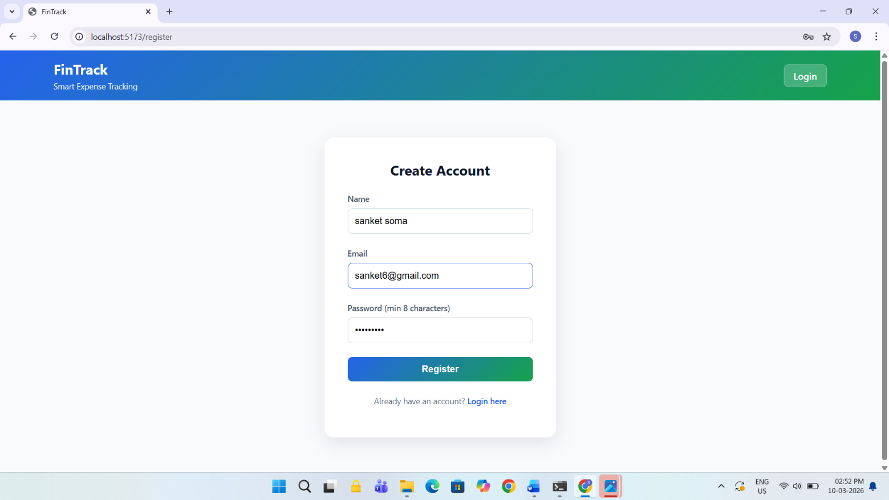
Sample user login
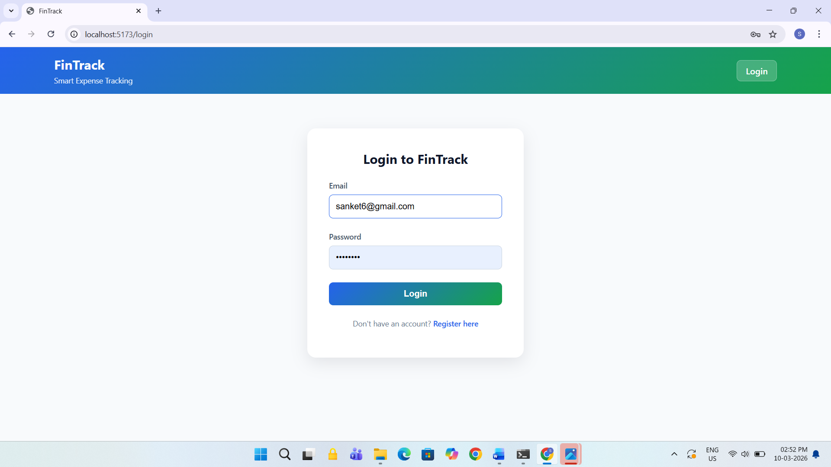

Annexure 2 – Output Reports with Data

Dashboard (Home Page)
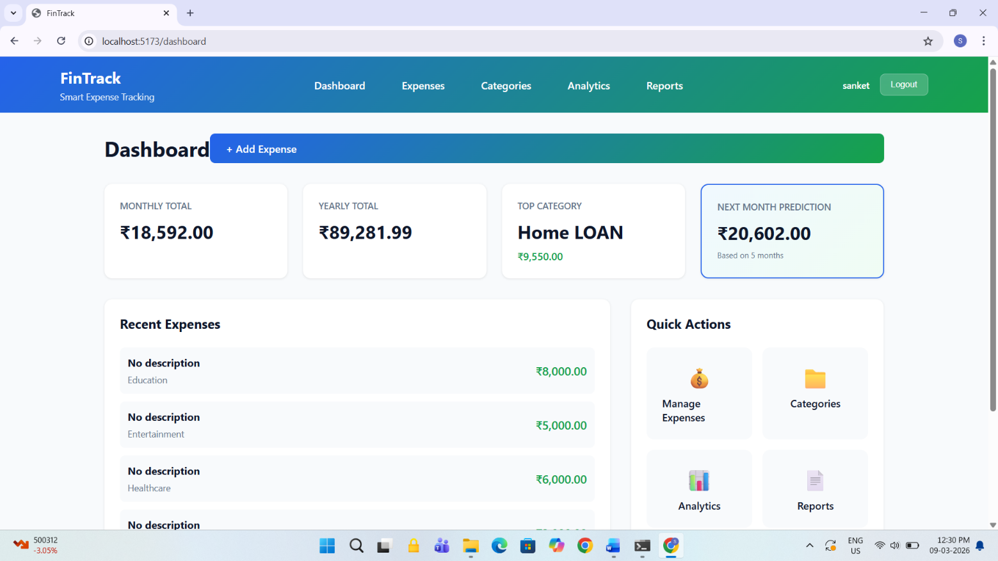

Sample Expense Entry Data
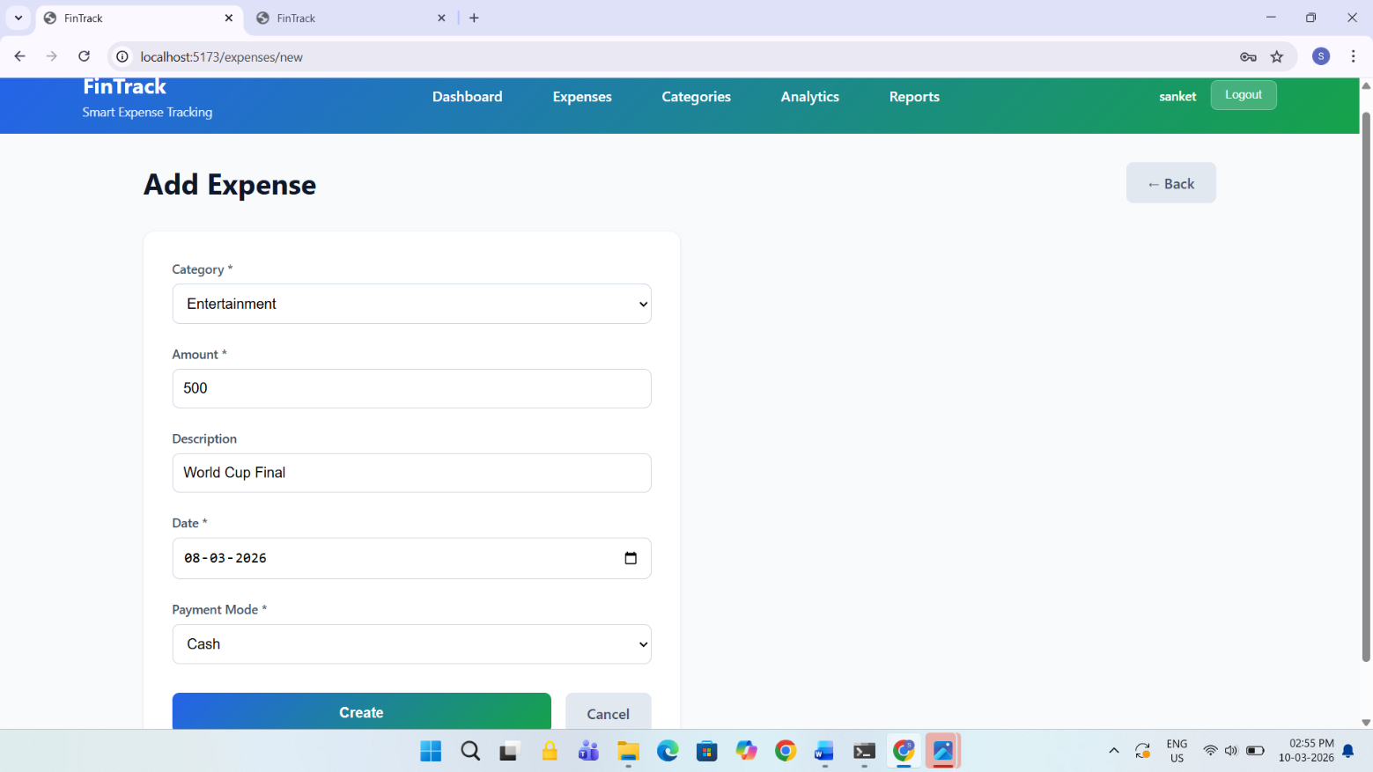

Sample Expenses
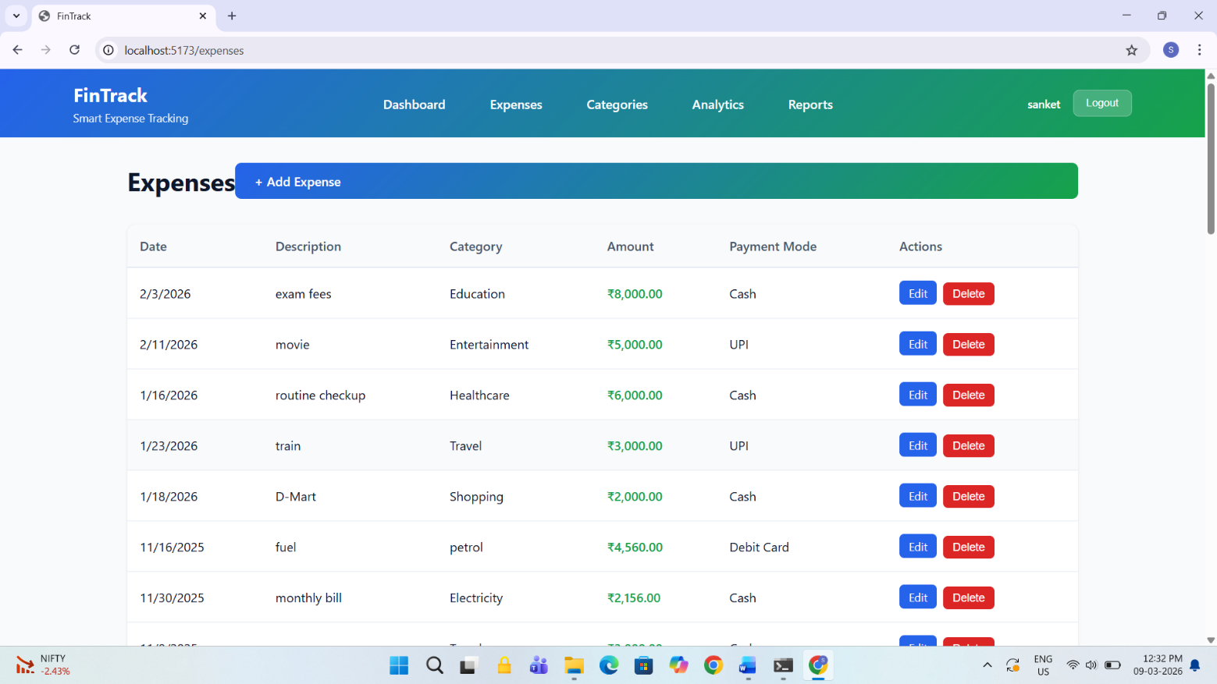

Sample Analysis & insights hhgj
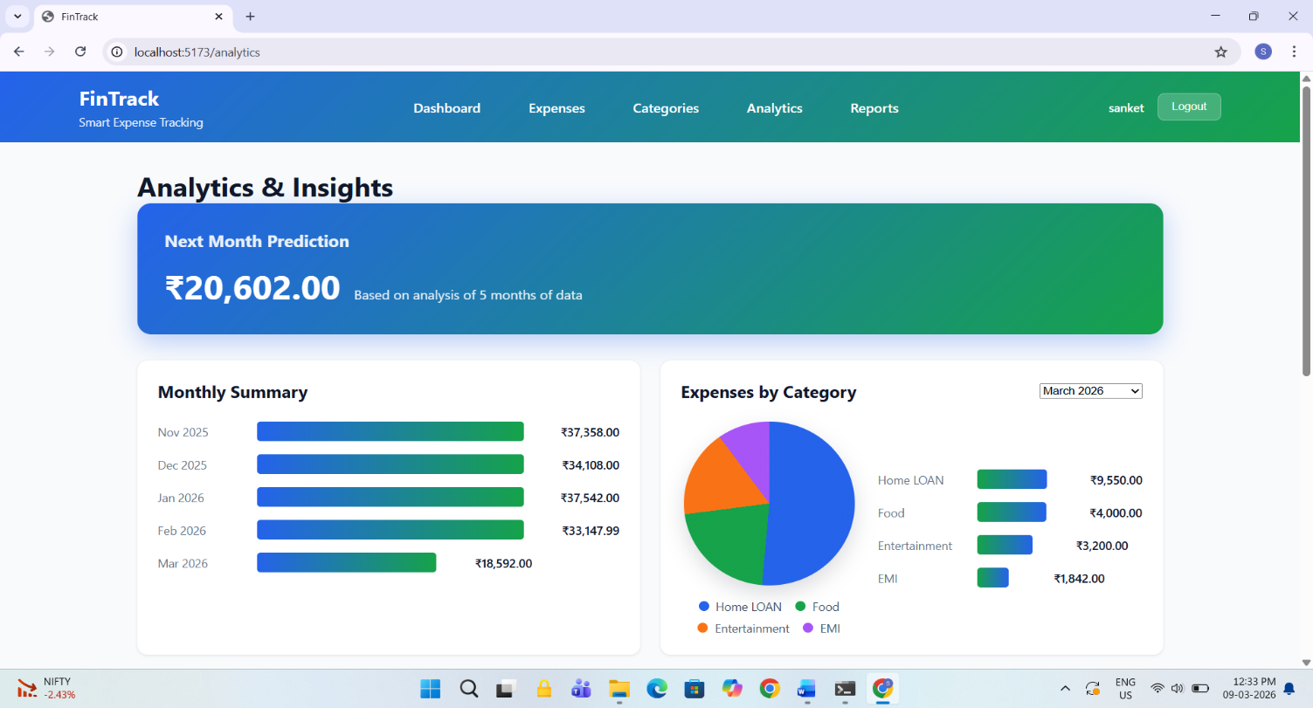

Sample Export Reports
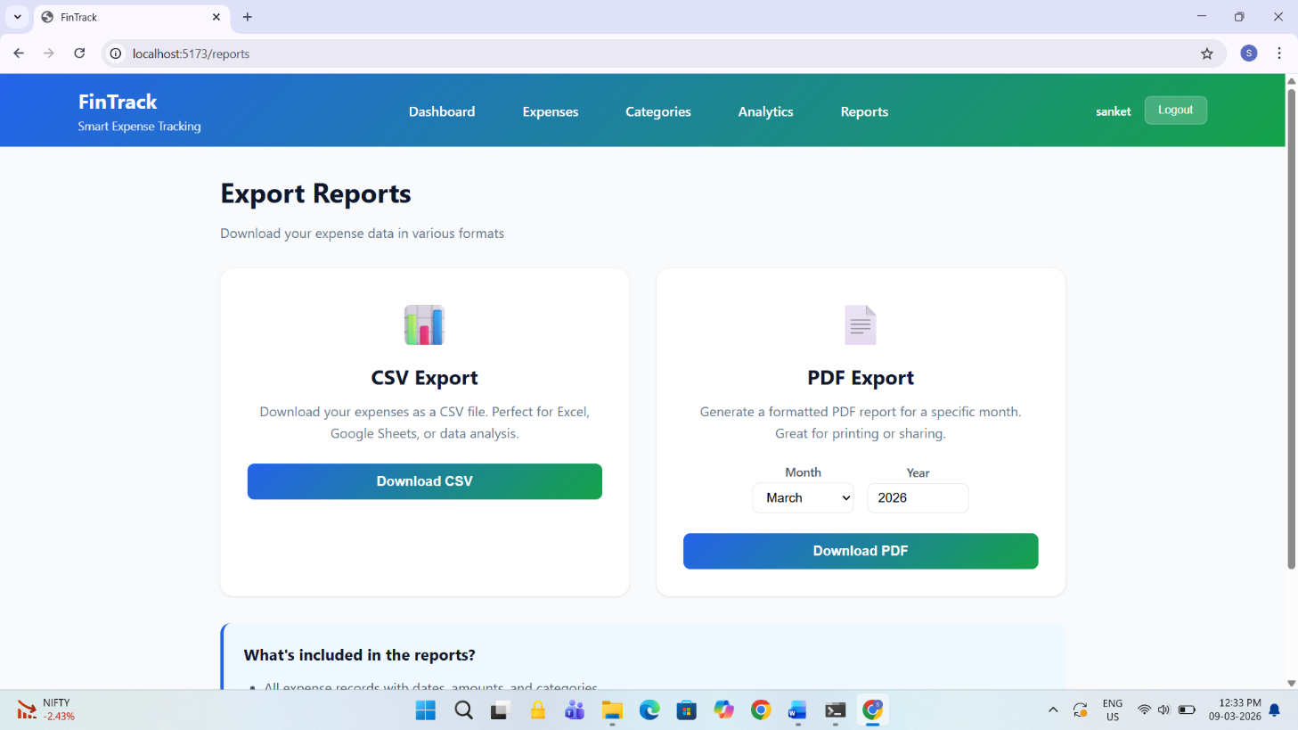

Sample Exported PDF -

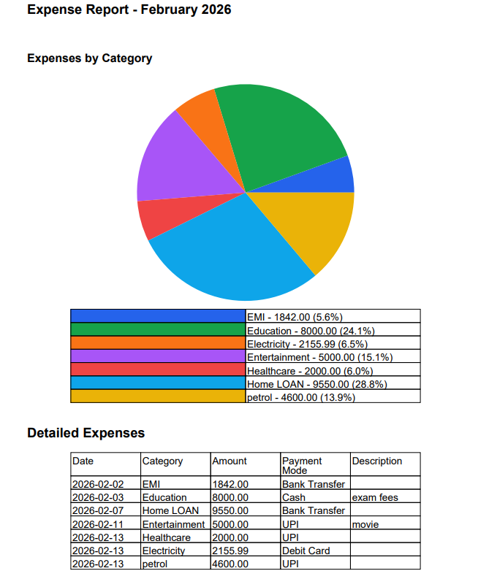

Annexure 3 – Sample Code

User Entity – User.java
@Entity
@Table(name = "users")
public class User {
@Id
@GeneratedValue(strategy = GenerationType.IDENTITY)
private Long id;
@NotBlank
@Column(nullable = false)
private String name;
@Email
@NotBlank
@Column(nullable = false, unique = true)
private String email;
@NotBlank
@Size(min = 8)
@Column(nullable = false)
private String password;
@Column(nullable = false)
private String role = "USER";
@Column(nullable = false)
private LocalDateTime createdAt;

Security Configuration – SecurityConfig.java (excerpt)
@Configuration
@EnableWebSecurity
@EnableMethodSecurity
public class SecurityConfig {
@Bean
public SecurityFilterChain filterChain(HttpSecurity http) throws Exception {
http
.cors(cors -> cors.configure(http))
.csrf(csrf -> csrf.disable())
.authorizeHttpRequests(auth -> auth
.requestMatchers(
"/api/auth/**",
"/swagger-ui.html",
"/swagger-ui/**",
"/v3/api-docs/**",
"/api-docs/**")
.permitAll()
.anyRequest().authenticated())
.sessionManagement(session -> session.sessionCreationPolicy(SessionCreationPolicy.STATELESS))
.authenticationProvider(authenticationProvider())
.addFilterBefore(jwtAuthenticationFilter, UsernamePasswordAuthenticationFilter.class);
return http.build();
}
}

Expense Controller – ExpenseController.java (excerpt)

@RestController
@RequestMapping("/expenses")
public class ExpenseController {
private final ExpenseService expenseService;
public ExpenseController(ExpenseService expenseService) {
this.expenseService = expenseService;
}
@PostMapping
public ResponseEntity<ExpenseResponse> createExpense(@Valid @RequestBody ExpenseRequest request) {
return ResponseEntity.status(HttpStatus.CREATED).body(expenseService.createExpense(request));
}

@GetMapping
public ResponseEntity<List<ExpenseResponse>> getExpenses() {
return ResponseEntity.ok(expenseService.getExpenses());
}
@GetMapping("/{id}")
public ResponseEntity<ExpenseResponse> getExpense(@PathVariable Long id) {
return ResponseEntity.ok(expenseService.getExpenseById(id));
}
@PutMapping("/{id}")
public ResponseEntity<ExpenseResponse> updateExpense(@PathVariable Long id,
@Valid @RequestBody ExpenseRequest request) {
return ResponseEntity.ok(expenseService.updateExpense(id, request));
}

